**SE Mini Project - 1A**

**Online Doctor System**

SE mini Project report submitted in partial fulfilment

of the requirement of the degree of

**INFORMATION TECHNOLOGY**

By

**Parth Jain (51) [SEIT 1]**

**Anikesh Kulal (65) [SEIT 1]**

**Parvez Khan (61) [SEIT 1]**

**Atharva Kadu (57) [SEIT 1]**

Under the guidance of

Ms. Vaishali Patil



Department of Information Technology

Atharva College of Engineering, Malad(W)

University of Mumbai

2022-23

**CERTIFICATE**

This is to certify that the S.E. mini-project entitled “**Online Doctor System**” is a bonafide work of **Parth Jain (51) [SEIT 1], Anikesh Kulal (65) [SEIT 1], Parvez Khan (61) [SEIT 1] and Atharva Kadu (57) [SEIT 1]** submitted to University of Mumbai in partial fulfilment of the requirement for the award of the degree of **“Information Technology”** during the academic year 2022–2023.

**Ms.Vaishali Patil**

**Prof. Dipali Maste**

Head of Department

**Dr. S.P. Kallurkar**

Principal

**S.E. Mini-Project Report Approval**

This mini-project synopsis entitled **“Online Doctor System”** by **Atharva kadu, Anikesh kulal, Parvez khan** and **Parth jain** is approved for the degree of **Information Technology** from **University of Mumbai**.

**Examiners**

1.

2.

Date:

Place:

**Declaration**

We declare that this written submission represents our ideas in our own words and where others’ ideas or words have been included, we have adequately cited and referenced the original sources. We also declare that we have adhered to all principles of academic honesty and integrity and have not misrepresented or fabricated or falsified any idea/data/fact/source in our submission. We understand that any violation of the above will cause disciplinary action by the Institute and can also evoke penal action from the sources which have thus not been properly cited or from whom proper permission has not been taken when needed.

Parth jain (51)

Anikesh Kulal (65)

Parvez Khan (61)

Atharva Kadu (57)

Date:

**Abstract**

Sometimes we come across small problems where we need to consult doctors about our health problems or for the nearest ones and follow their prescriptions. Online Doctor System will provide us the power of direct interaction between doctors of our choice as and when required for our small problems. Using this web Online Doctor System applications, patients will able to fill online form in just few seconds before entering to the virtual office room. It will also enable us to upload our lab results such as x-ray copies, health history, etc. which can be viewed by our referred doctors.

**Table of Content**

|  |  |  |
| --- | --- | --- |
| **Chapter** | **Topic** | **Page No.** |
|  | **Abstract** | 6 |
|  | **List of Figures** | 8 |
|  | **List of Tables** | 9 |
| **Chapter 1** | **Introduction** | 11,12 |
|  | 1.1 Motivation | 13,14 |
|  | 1.2 Problem Statement | 15 |
|  | 1.3 Objectives | 16 |
|  | 1.4 Scope | 17 |
| **Chapter 2** | **Review of Literature** | 18 |
| **Chapter 3** | **Existing System and Proposed system** | 19 |
| **Chapter 4** | **Methodology** | 20 |
|  | 4.1 Block diagram | 21 |
|  | 4.2 Technology Used | 22 |
|  | 4.3 Implementation | 23 |
|  | 4.3.1 Algorithm/Flowchart | 24 |
|  | 4.3.2 Pseudo code |  |
| **Chapter 5** | **Results and Discussion (**Screenshots of the output with description ) | 26 |
| **Chapter 6** | **Conclusion** | 27 |
| **Chapter 7** | **Future Scope** | 28 |
|  | **References** | 29 |

## **List of Figures**

|  |  |  |
| --- | --- | --- |
| **Figure No.** | **Figure Name** | **Page No.** |
| 1 | Existing System Block Diagram | 19 |
| 2 | System Block Diagram | 19 |
| 3 | Admin Menu | 21 |
| 4 | Doctor Details | 22 |
| 5 | Registration Page | 22 |
| 6 | User Menu | 23 |
| 7 | Speciality | 23 |
| 8 | Book Appointment | 24 |
| 9 | Available Doctors | 24 |
| 10 | Block Diagram | 25 |
| 11 | Block Diagram | 26 |

**Chapter 1**

**Introduction :**

Aim of this project is to create doctor patient handling management system that will help doctors in their work and will also help patients to book appointments online and reports. The system allows doctors to manage their booking slots online. Patients are allowed to book empty slots online and those slots are reserved in their name. The system manages the appointment data for multiple doctors of various date and times. Each time a user visits a doctor his/her medical entry is stored in the database by doctor. Net time a user logs in he/she may view his/her entire medical history as and when needed. At the same time a doctor may view patient’s previous medical history while the patient visits him. If someone is ill or wants a check-up, they need to wait for the doctor to be available and has to wait in a queue for their turn. If the doctor cancels the appointment for some emergency reasons then the patient is not able to know about the cancelation of the appointment unless or until he or she visits the hospital. As the online Appointment system is developing rapidly therefore one can use the system to overcome such problems and inconvenience for the patients. .An intelligent agent based appointment system has been proposed in which a scheduling system is provided for patients. The junior medical staff schedules appointment according to the priority level. Searching doctors and hospitals along with navigation details are also available in the system so they can get proper treatment on time. This appointment based application can be used with other appointment based systems. This system serves the purpose of establishing an online interaction between a doctor and patient. Generally when doctors are not available or not reachable to patients and vice versa, this app will facilitate both the patients and doctors to interact or communicate and seek some help from the doctor regarding patients health condition concerns etc. Always it may not be possible for a patient to meet doctor in hospital/clinic due to some busy schedule and similarly for doctor it may not be possible to give an appointment for the patient to clear minor issues or doubts that the patient has. In such cases it will be helpful to have a medium of online interaction where the patient can quickly ask the doctor some Questions.

**Motivation:**

The online scheduling systems are also known in many names such as online booking application, online scheduler, online scheduling software, and more. It is one of the most commonly used web-based applications and enables individuals to securely and conveniently book their reservations and requests online via a laptop, tablet, smartphone, computer, and other web-connected devices.

Anyone can access the online appointment management system via the URL provided by the healthcare or medical facility or through a “Book Now” button in the website. Once the time and date are selected, the system confirms the bookings automatically and also records it within the system instantly without any intervention from the staff.

The online appointment management system also comes with features like automated text and email message reminders, which is sent to the booked patients or individuals on the date booked before their scheduled time of booking. The flexibility of the online appointment management system in healthcare includes

Booking inoculations and vaccine in hospitals.

Scheduling a patient’s treatment, services, and appointments.

Time-Saving:

The staff spends less time on managing appointments, and phone booking, and can, therefore, use their free time for more urgent and vital tasks. The patients can also save time as there is no need for calling the hospital and booking an appointment in the middle of their busy schedule.

For example, consider a large medical facility hospital which schedules 100 plus appointments daily. Every appointment calls are handled by the support staff from the administration, and they spend approximately 3 to 4 minutes on a phone call.

In this case, if the healthcare facility switches to an online booking system it can save most of their time and also get more time to deal with other pressing tasks in the facility.

Monetary Savings:

The time savings made by the facility can translate automatically into monetary savings as a reduction in services and staff translates into a reduction in expenses. The appointment management system can reduce the need for extra human resources created by the process of appointment scheduling.

24 hours convenience:

An individual is needed to schedule an appointment over the phone calls during the office hours, and therefore people need to work round the clock on the phone booking. With online appointment management system, the individual or the patient can book an appointment any time. It is seen that after business hours there is more than 55 percent of all appointments booked through online scheduling appointment systems.

**Problem Statement**

Under manual system, people have to wait in long queues for booking appointment. Using online doctor system, user can skip this step and book appointments directly from his home.

There is no general place to book appointments for all the doctor, except for physically visiting the clinic. The admin can manage the doctor details and availability, so the user can check whether his desired doctor is available for the selected time.

In doctor system, admin can add multiple doctors in the same page, so the user can select the doctor who fit his needs.

This project works as being a general place to view and book appointments for many doctors at the same place.

**Objectives**

The objective of this project is to make an online doctor appointment system which is built using JAVA Swing and MySQL. Using this work, we can maintain electronic medical records of users which will lead to ease of management. We can reserve appointments for our desired doctors and the whole process is carried out online. The user can see the available time slots for various doctors. The user can also cancel his booked appointment a few hours before his appointed time. Medical diagnosis report and medical Suggestion, etc. will be given to patient via email and other media and will be stored in the clinical centre database as well. The user can also leave a feedback/complaint which is helpful to make the service better for the future.

**Scope**

The digital revolution has bought everything close together. In this fast-paced life, all these services are only a click away.

The Healthcare sector has also gone online with their appointment booking and other necessary details. While some hospitals opt for their appointment system, some also use online platforms through which patients can book an appointment. Online appointments in India It was not long back when one had to either call the hospital or the doctors' reception to book an appointment. It is accompanied by a waiting list at the hospital and then finally meeting the doctor. Things have now changed, in India various doctors and hospitals are providing the option to book online appointments.

**Chapter 2**

**Review of Literature**

**Web-Based Medical Appointment Systems: A Systematic Review**

By David Miller, Ping Yu, and Xiaojun Zhang, Peng Zhao, Illjoi Yoo and Jaie Lavoie

The purpose of this study was to identify the benefits and barriers to implement Web-based medical scheduling discussed in the literature as well as the unmet needs under the current health care environment. The literature suggests a growing trend for the adoption of Web-based appointment systems. The findings of this review suggest that there are benefits to a variety of patient outcomes from Web-based scheduling interventions with the need for further studies.[1]

**Mr. Doc : A Doctor Appointment System**

By Shafaq Malik, Nargis Bibi and Sehrish Khan

The main idea of this work is to provide ease and comfort to patients while taking appointment from doctors and it also resolves the problems that the patients has to face while making an appointment. The android application Mr.Doc acts as a client whereas the database containing the doctor’s details, patient’s details and appointment details is maintained by a website that acts as a server.

**Chapter 3**

**Existing and Proposed System**

Under manual system, we have to first wait in line to take appointment for the doctor and wait for our time to meet with them and discuss on our health problem. We have to be present physically at the doctor’s cabin. Under manual system, the only accepted payment method is by cash and if patients due to some reasons are not having cash on time may face difficulties and not able to get treatment. There is no general place, where all the doctors can be viewed at the same place. User can either physically visit the doctor or visit their websites, but that becomes a hassle for the user. The doctor might not be available at a given time, so the patient might have to turn back after visiting the clinic.

Existing System

Manually Visiting

Long Queues

Doctor might not be available

Hospital/Clinic’s Website

Different websites for different doctors

Figure 1

To make a truly online system to have meet with online doctors, all manual process has been automated through this system. Patient have to fill online form by which id and password created and sent to their email and upon accepting data, automatic login to patient panel.

Through this panel, patients can select the doctors and have appointment with them on their time from their own place.

Under our project, the user will get all the available doctors at the same place.

The admin can set the availability of the doctor at a given time, so the user can only view available doctors.

**Chapter 4**

**Methodology**

We created windows for user and admin login. The user can register and login to his account and the login details are stored in a database which can be accessed by the admin. After logging in, he can select the type of treatment he needs and the respective doctors will be shown. He can select his desired doctor, book an appointment and proceed to the payment page. Under User Menu, he select an option to leave his feedback or report any queries he/she faced. The doctors shown to the user are stored in a database which can only be accessed by the admin. Jconnector library is used to connect the database to the program.

The next module is Admin menu. The admin can access/edit doctor and user data from the database. He can also receive the feedbacks/queries/complaints of user. The admin’s role is to be the moderator between the doctors and users.

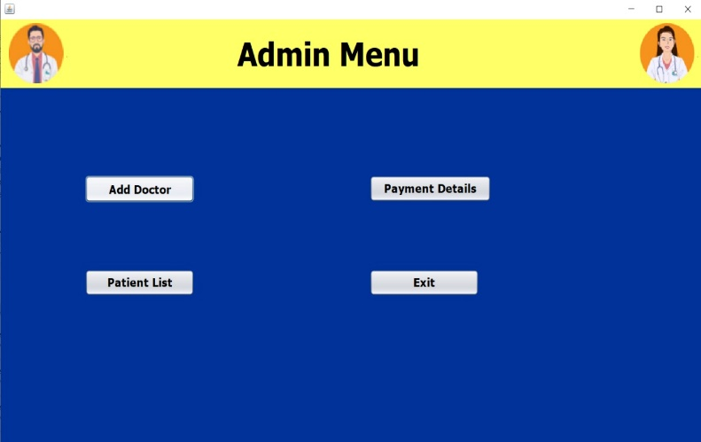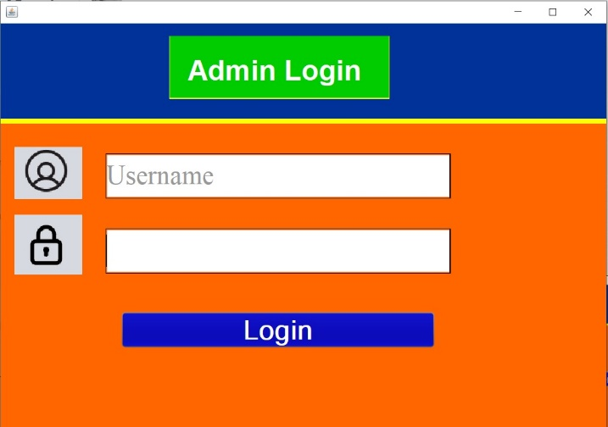

**Block Diagram**

Patient

**Automated online doctor system**

Admin

Request approved/reject

Appointment Request

Add/delete Doctors

View patient Details

View Payment History

*Figure 2*

**Technology Used**

* Frontend: Java, Java Swing, Netbeans
* Backend: Java, MySQL
* Database: MySQL for data management
* Libraries: Jconnector for mysql connection with java netbeans, JCalendar for date input in JFrame.

**Implementation**

The current health care landscape desired efficiency and patient satisfaction for optimal performance. In this work, a patient appointment and scheduling system is designed using Java Swing for the frontend and MYSQL for the backend.

The user can be an Admin or a normal user, after logging in, the user can view the available list of doctors, cancel his booked appointment and book an appointment for the selected doctor.

The Admin can view/modify user data, doctor data and act as a moderator.

The database is stored on a server, so it can be accessed by the program and we’ve used Jconnector library to form the connection between the database and program.

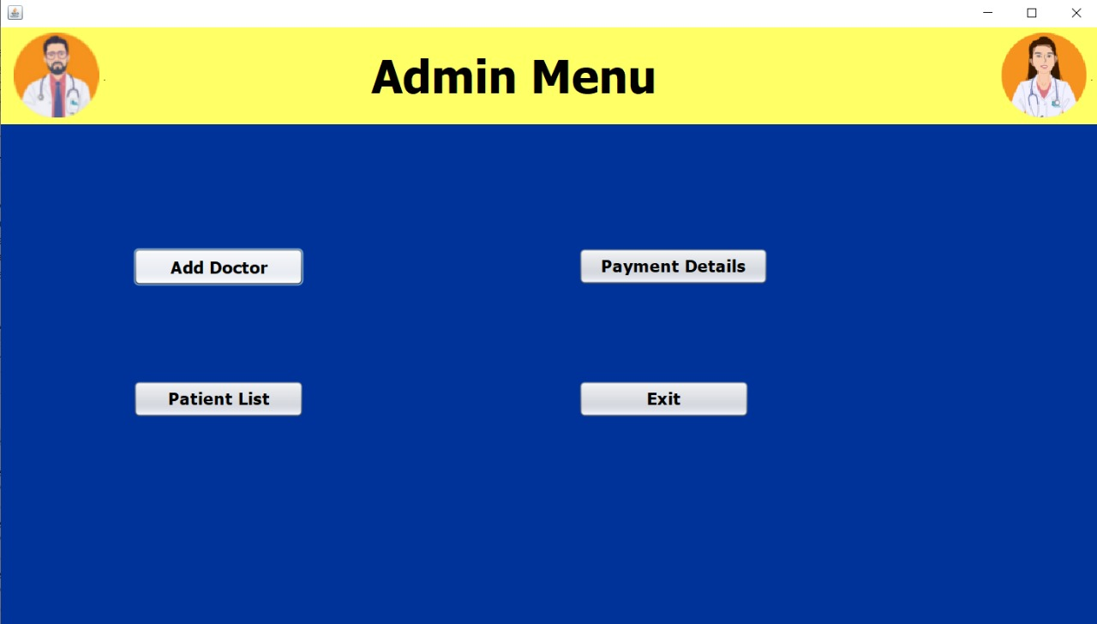

*Figure 3*

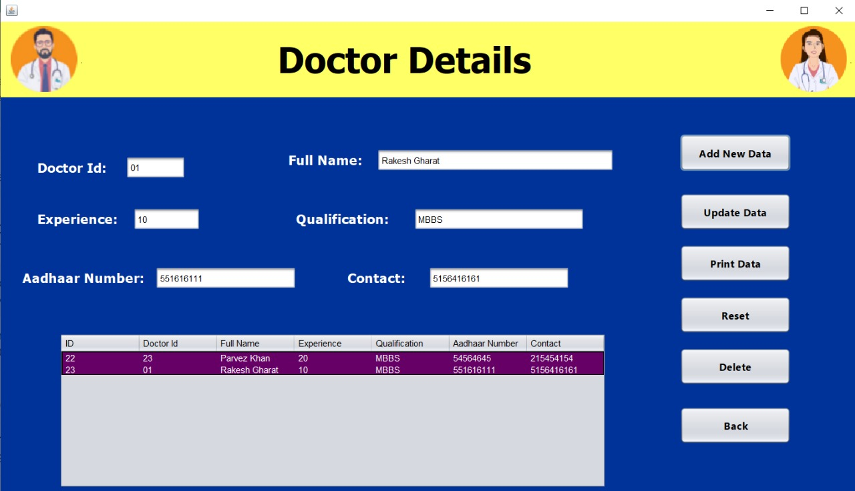

*Figure 4*

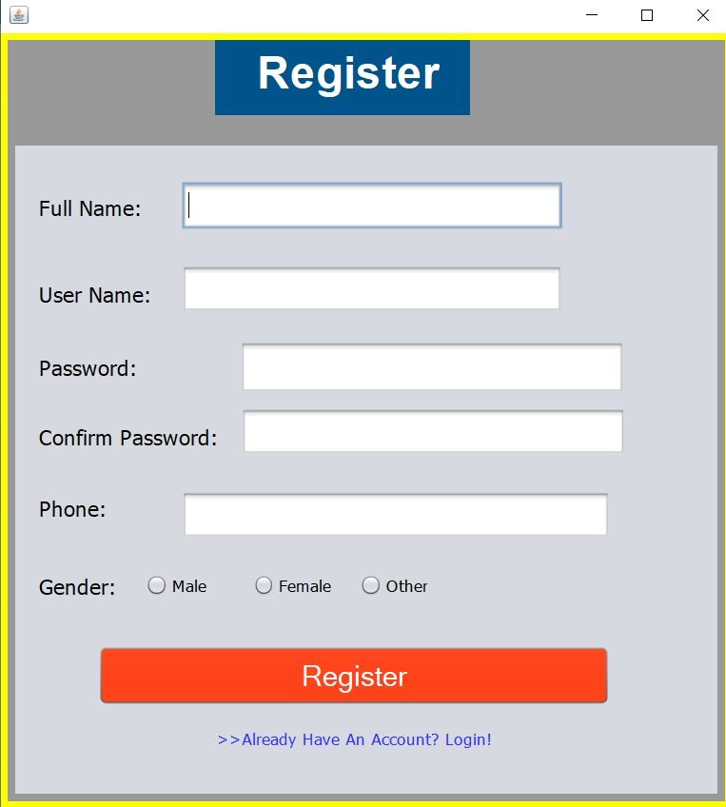

*Figure 5*

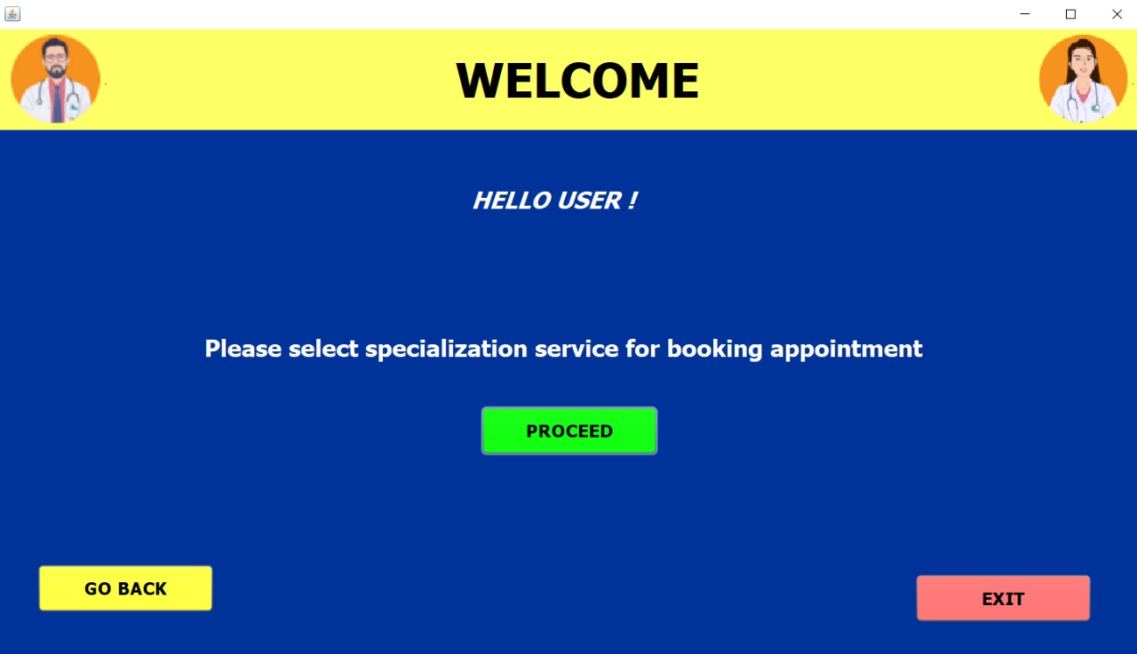

*Figure 6*

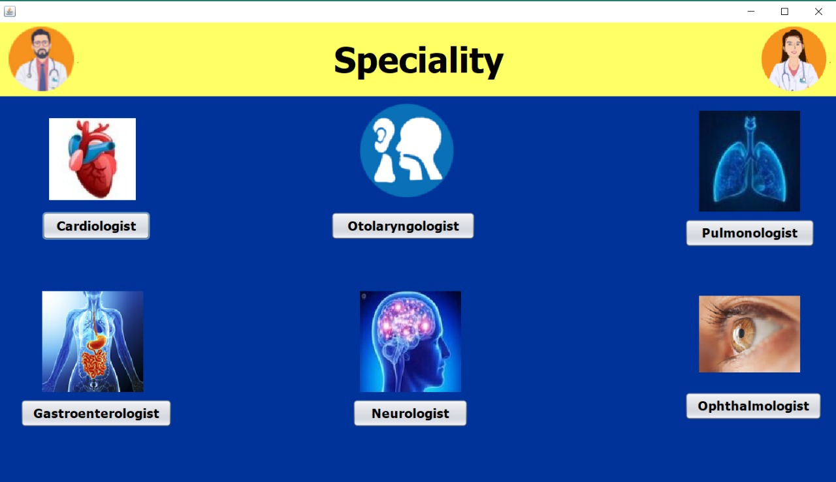

*Figure 7*

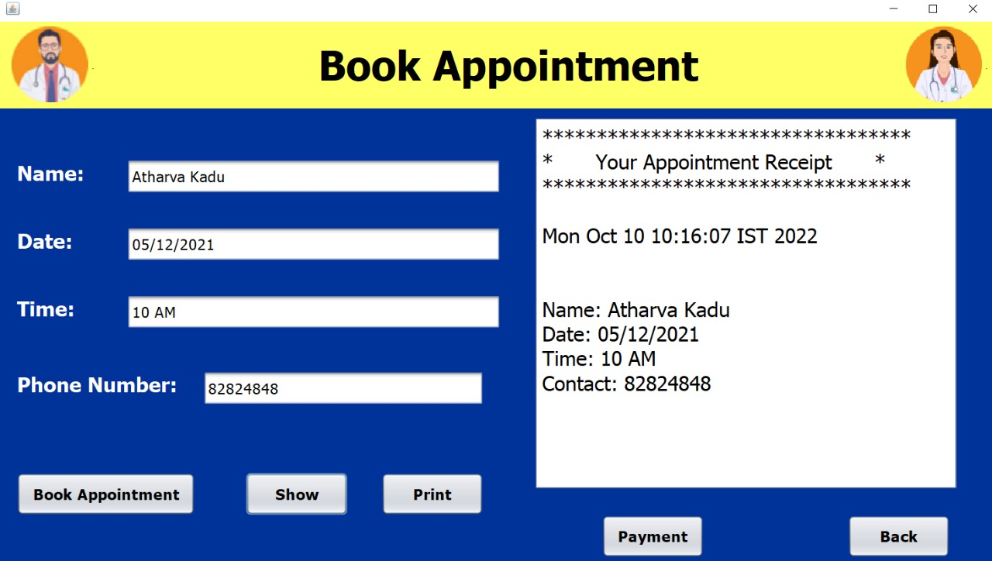

*Figure 8*

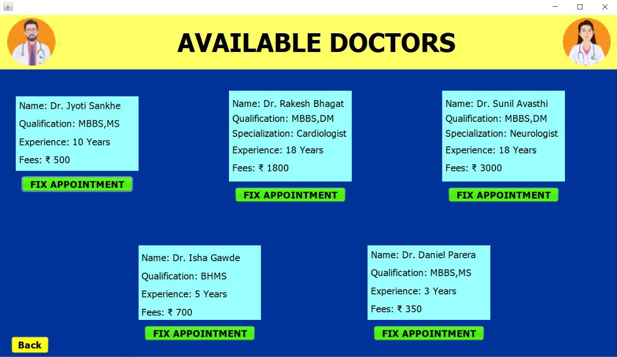

*Figure 9*

**Algorithm/Flowchart**

Payment

Module

Admin Module

User Module

Find Doctor

Module

Appointment

Module

Detail of User

*Figure 10*

Find Doctors

Make Payments

Online

Book

Appointments

Manage “My

Profile”

Login/Logout

User

View Payment History

View/Modify Doctor List

View/Modify Patient List

*Figure 11*

**Pseudo code**

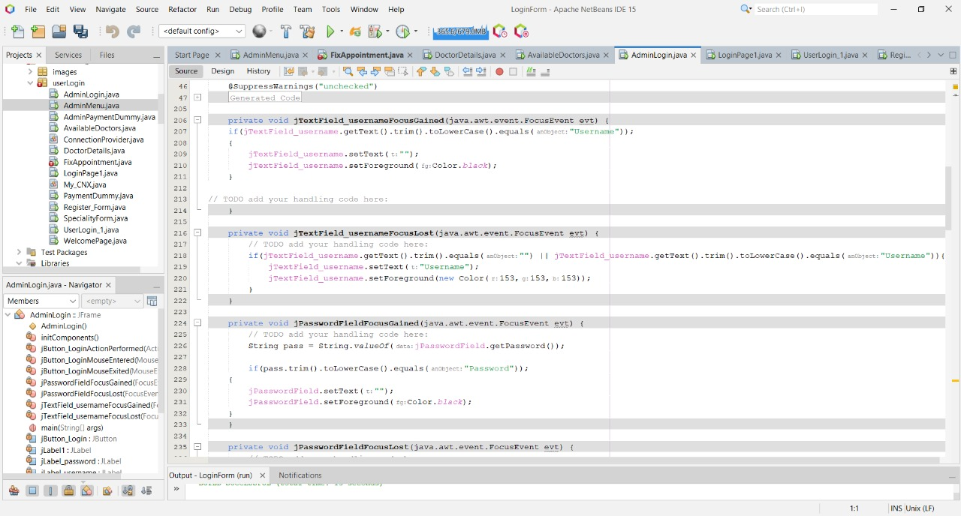



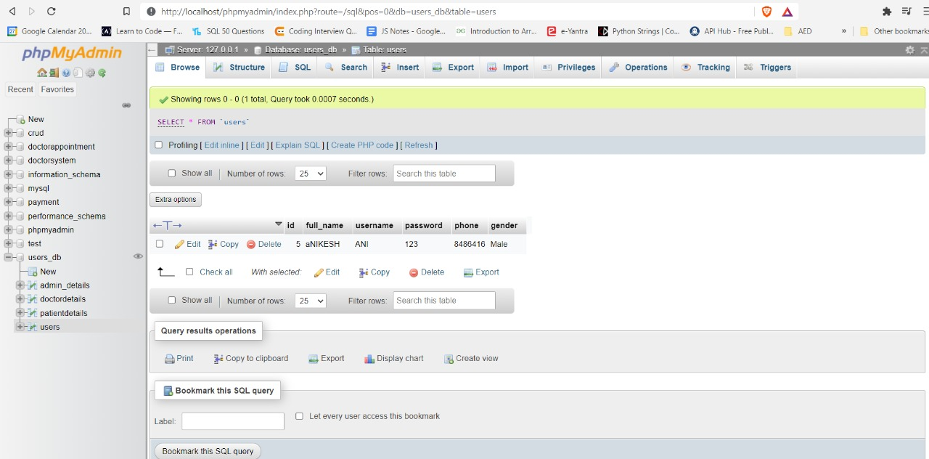

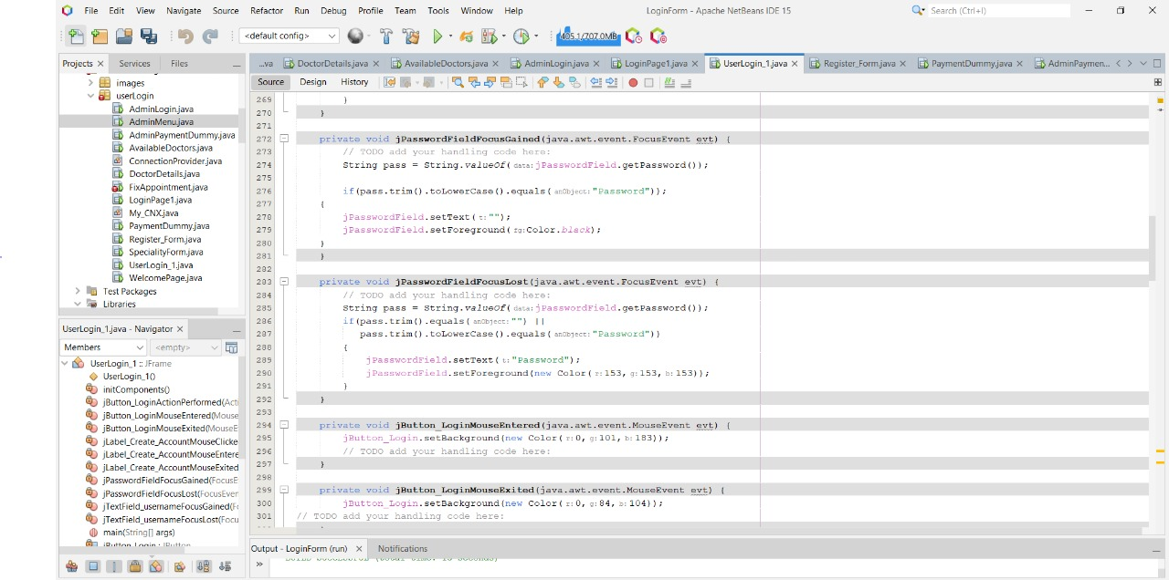

**Chapter 5**

**Result and Discussion**

Online systems make patient management easier and more efficient. Some online scheduling systems for appointments also have management of patient health records as part of the package. The organization can create a single point from which to save, update, manage and analyse patient information.

Recording, reporting and analysing such information helps to efficiently manage the case file of a patient. All regularly recorded patient information, along with a history of check-ups and associated medical tests, can be used to make educated, carefully considered health care decisions. This can reduce the amount of documentation and the time it takes to access physical files.

It is also possible to avoid redundant data entries about the same patient. In addition, the ongoing records of the patient can be updated at each appointment, making patient information available for easy and fast access in one place. This is important when two different practitioners are consulted at the same facility by a patient.

**For example,** it may be more convenient for a patient consulting a dentist and an orthodontist at the same facility to have information stored at a single point, as the dentist would like to be informed about the ongoing orthodontic treatment of the patient in order to assess how best to handle the specific oral hygiene needs of the patient.

In the same facility under another doctor, a quick reference to the current orthodontic procedures that the patient undergoes is all it takes for the dentist to plan his procedure. It saves time and ensures complementary and coordinated overall services are provided. Such systems become a common interface to access information about a single patient by different medical staff. This can go a long way in strengthening the care process of a patient.

**Chapter 6**

**Conclusion**

After finishing up our project we have to state that, we tried our best in order To develop the software in the most suitable ,helpful and easiest method that can be used by the user easily. User can easily pickup their expected information based upon their privilege .This is web based software and it will be going to accessible from any computer by using internet.

We have tested the system using several technique to determine the system flexibility. We tried to develop automated online doctor system which recover as possible the drawbacks and limitation compare to this type of existing software as well as for efficient use for users. It will save money, time and energy to appoint a doctor. Provide safety and security to data enable the system administrator to authenticate all of the users through user name and password sop that unauthorized user do not get access to the hospital data.

**Chapter 7**

**Future Scope**

1. Make the system fully automated.
2. Implement security System for the project.
3. Make the system more flexible for payment and other transaction.
4. Develop mobile app for the system.

**Reference:**

1. “Web-Based Medical Appointment Systems: A Systematic Review”

By David Miller, Ping Yu, and Xiaojun Zhang, Peng Zhao, Illjoi Yoo and Jaie Lavoie

Journal of Medical Internet Research

[**https://www.readcube.com/articles/10.2196%2Fjmir.6747**](https://www.readcube.com/articles/10.2196%2Fjmir.6747)

1. Mr. Doc: A Doctor Appointment Application System:

By Shafaq Malik, Nargis Bibi and Sehrish Khan

[International Journal of Computer Science and Information Security](https://www.researchgate.net/journal/International-Journal-of-Computer-Science-and-Information-Security-1947-5500).

[**https://www.ijera.com/papers/vol12no4/Ser-3/I1204034852.pdf**](https://www.ijera.com/papers/vol12no4/Ser-3/I1204034852.pdf)

1. Maryam Tufail ,"Online Polyclinic Appointment and Database Management System ",Master's thesis 43 pages, appendices 1 page ,August 2018.

<https://www.theseus.fi/bitstream/handle/10024/152390/Tufail_Maryam.pdf?sequence=1&isAllowed=y>

1. Irin Sherly. S , Mahalakshmi. A , Menaka. D , Sujatha. R," Online Appointment Reservation and Scheduling for Healthcare- A Detailed Study", International Journal of Innovative Research in Computer and Communication Engineering , Vol. 4, Issue 2, February 2016.

<https://www.ijstr.org/paper-references.php?ref=IJSTR-0919-22218>

1. A study and an implementation of online doctor consultation system:Journal of Applied Technology and Innovation (e -ISSN: 2600-7304) vo5. 1, no. 1, (2021) Wang Jack Huan

[**https://dif7uuh3zqcps.cloudfront.net/wp-content/uploads/sites/11/2021/01/30121409/A-Study-and-Implementation-of-Online-Doctor-Consultation-System.pdf**](https://dif7uuh3zqcps.cloudfront.net/wp-content/uploads/sites/11/2021/01/30121409/A-Study-and-Implementation-of-Online-Doctor-Consultation-System.pdf)